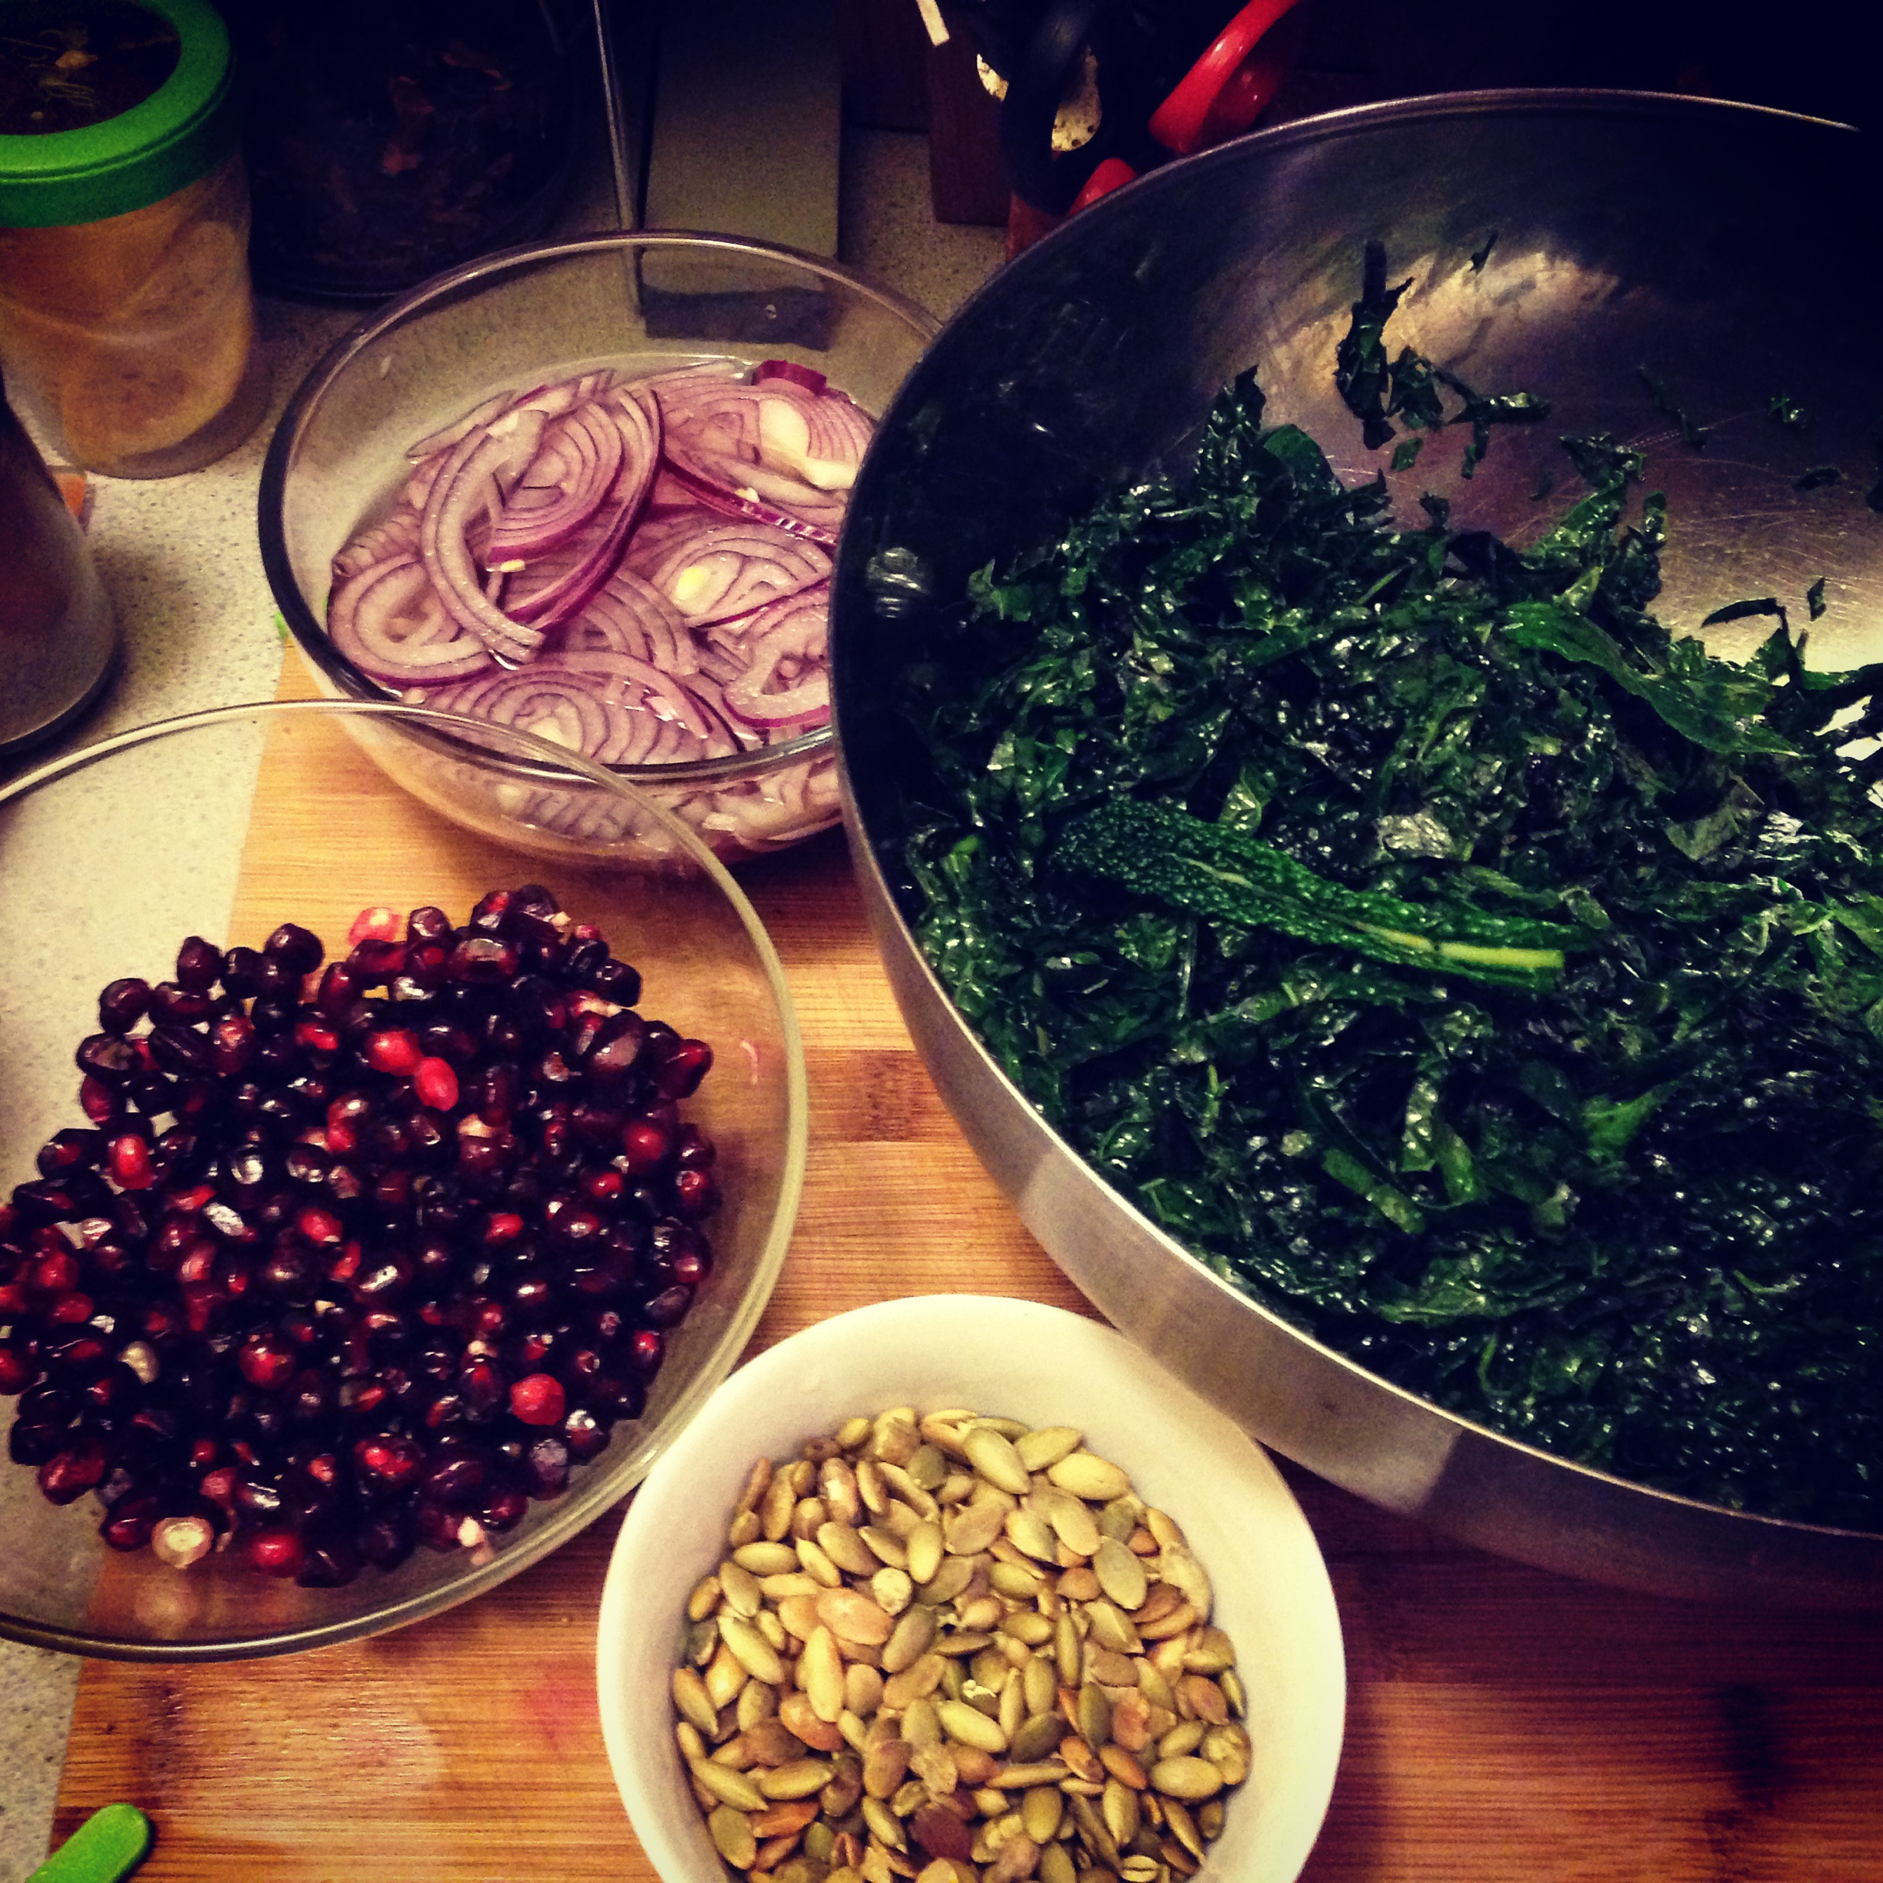

Emerald Kale Salad
(from Bauman College: Nutrition Essentials for Everyone, adapted from Catherine McConkie, Natural Chef Instructor)

Kale is a wonderful nutrient-dense green that is typically used in cooked dishes. However, in this recipe kale is enjoyed raw. To soften the greens, they are massaged with a little sea salt, making them tender and delicious. The fruit can be changed according to season. Pomegranate is nice for fall, blood oranges work well in winter, strawberries or kumquats are delicious in spring, and nectarines are a perfect addition in summer.

Ingredients

Dressing:
¼ cup raspberry vinegar
2 tsp lemon juice
¼ cup olive oil
sea salt and pepper
¼ cup pumpkin seeds (toasted)

Salad:
½ cup red onion, very thinly sliced
1 Tbs. apple cider vinegar
1 large bunch dino kale, stems removed, finely chopped
1 tsp sea salt
2 cups seasonal fruit

Directions
- Place the onion in a small bowl with the apple cider vinegar and cover with water. Let soak for 20 minutes. Rinse and squeeze out moisture.
- Prepare the kale as directed and place in large bowl. Drizzle with a little olive oil and sprinkle with sea salt. Massage the mixture with your hands, kneading and squeezing until the kale begins to wilt. Set aside.
- Add kale, onion, and seasonal fruit(s) of your choice to a large bowl. Toss to combine.
- Whisk together the raspberry vinegar and the lemon juice. Drizzle in the olive oil and whisk continuously until emulsified. Season with salt and pepper. Add the dressing to the salad, just enough to coat the ingredients. Toss in the pumpkin seeds and serve.

