Foodsoulutions | Season your life with love and cooking!
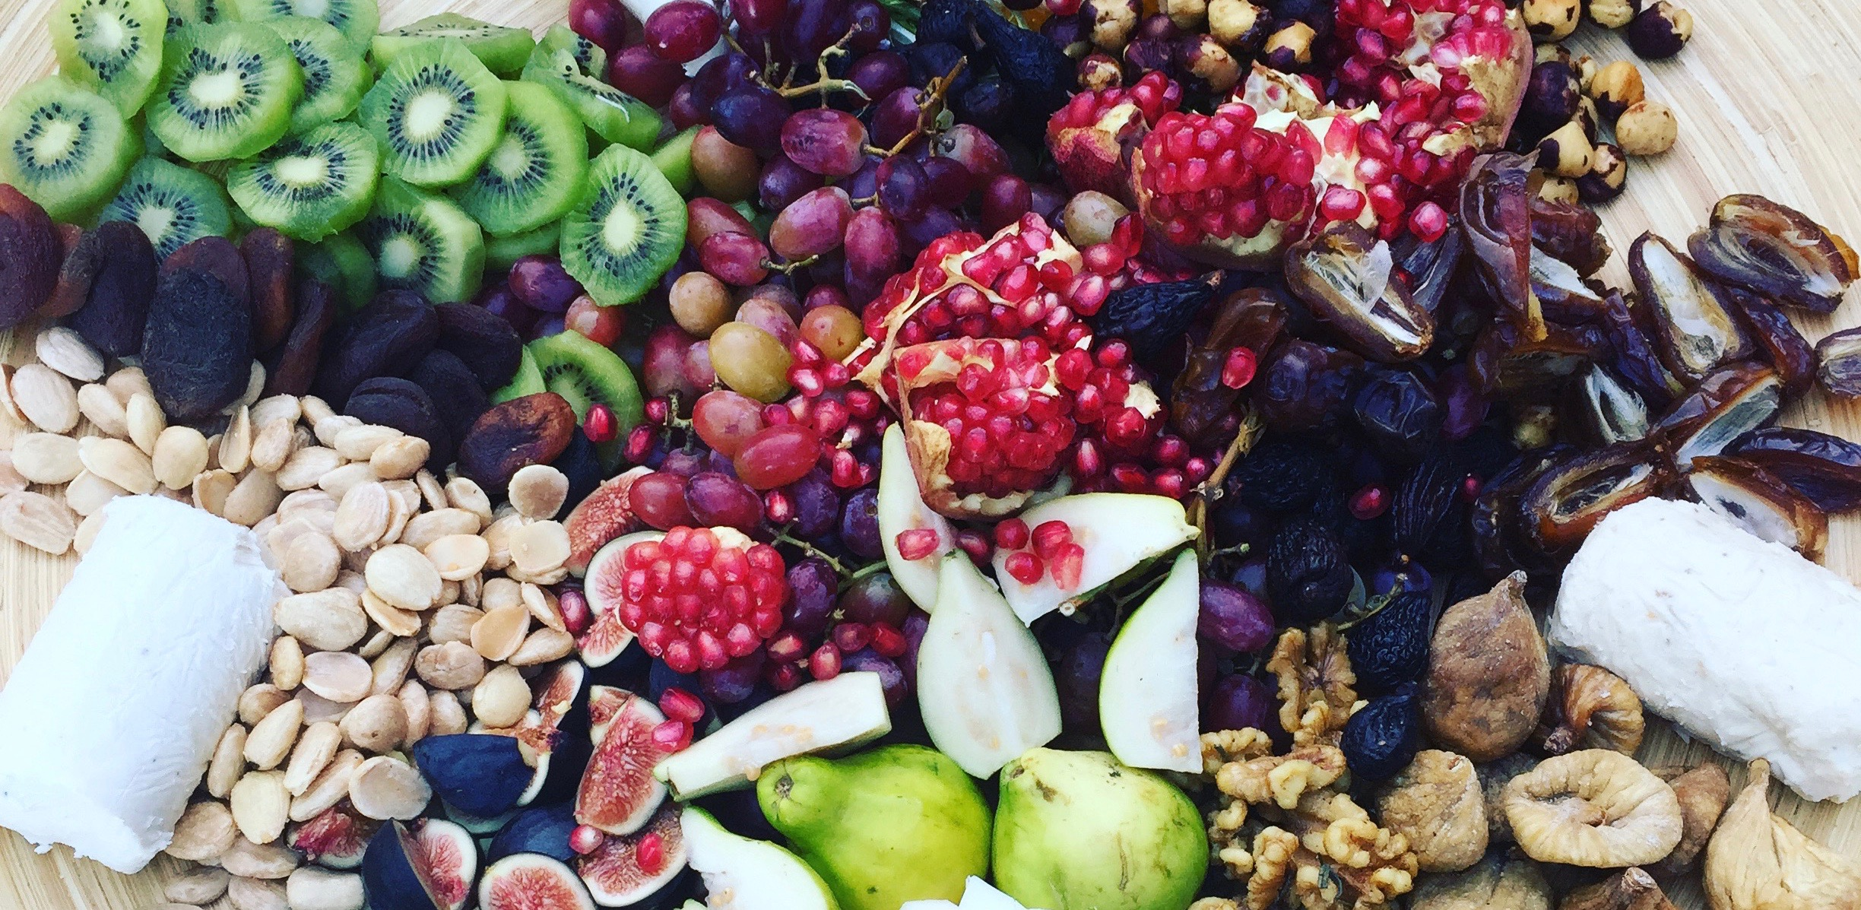
Appetizer Party for 50 (Sample Menu)
______________________________________________________________________
White Bean & Artichoke Hummus (with chipotle and pine nuts)
Seasonal Crudité (carrot, snap pea, watermelon radish, etc.)
Grilled Prawns (with Harissa and Lemon)
Turkey Meatballs with Cilantro Aioli
Blood Orange, Fennel, Pomegranate & Radicchio Salad
Assorted Artisanal Breads & crackers (Gluten-free options available)
Seasonal Cheese Platters: assorted cheeses, spiced nuts, & seasonal
fruits. (Charcuterie upon request).
Mini Chocolate Cupcakes with Espresso Frosting.

